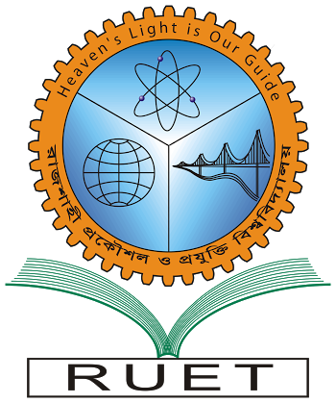“Heaven’s light is our guide”

**Rajshahi University of Engineering & Technology**

**Department of Computer Science & Engineering**

**Course Title: Object Oriented Programming Sessional**

**Course No: CSE 1204**

Submitted To:

***Rizoan Toufiq***

*Assistant Professor,*

*Dept. of CSE,*

*RUET.*

Submitted By:

***Saifur Rahman***

*Roll No: 1703018*

*Section: ’17-A*

*Class: 1st year (Even Semester)*

***Date of Submission: 24 Nov, 2018***